4CS015 – Portfolio Task #4
STUDENT NAME: Karan Sah
STUDENT NUMBER: 2329860
You will need to complete the workshop and then submit this Word file, complete with your answers, via Canvas, by the end of Semester (week 12).
For this assignment (workshop) you will show you how to navigate and create file systems from command prompt in both Windows (os) and Linux(os), also how to create a batch file to be executed in the Windows (os).
NOTE: Please make sure you have written your command as well as the screenshot of the commands. Failure to do so will result in marks deduction.
Task 1 (Windows Command Line)
md test
cd test
dir
echo hello>hello.txt
type hello.txt

- Write a command to Create a directory "test"
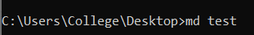
- Write the command to list all the directories/files inside the directory test
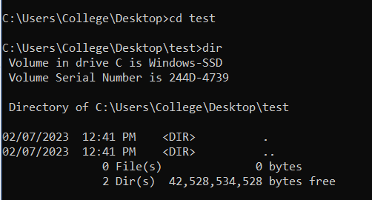
- Create a file "hello.txt" containing the word "Hello", inside the test directory.

- Display the content of hello.txt in the command line.
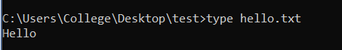
- Make directory test1 in the Desktop and copy hello.txt from test to test1
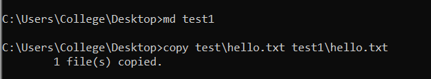
- Now delete the file hello.txt in the current directory
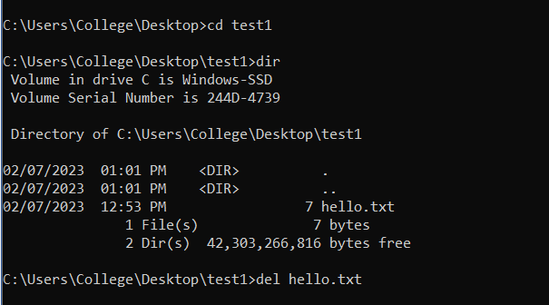
- Write a command to display your current directory.
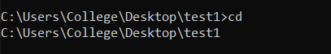
- Now rename the file to hello2.txt
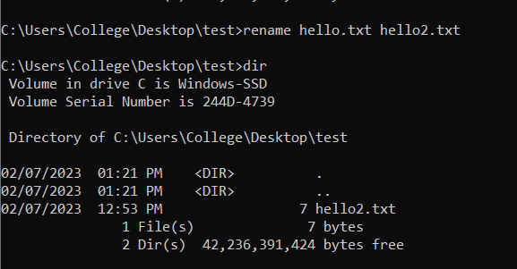
- Now navigate outside the directory test.
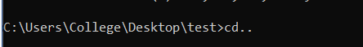
- Write the command to print the tree structure. It should look something like this:
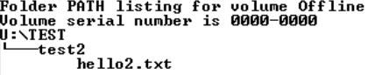
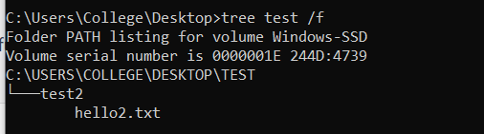

Task 2
Create the following directory structure and paste it after this picture. (15 marks):
Note: MYMODULES must be inside <your_name> directory.
Make a directory with your name on the desktop and navigate to the directory before you display the following structure.

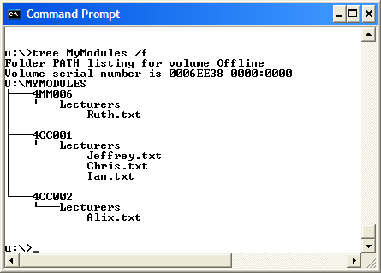

[Insert your picture here]

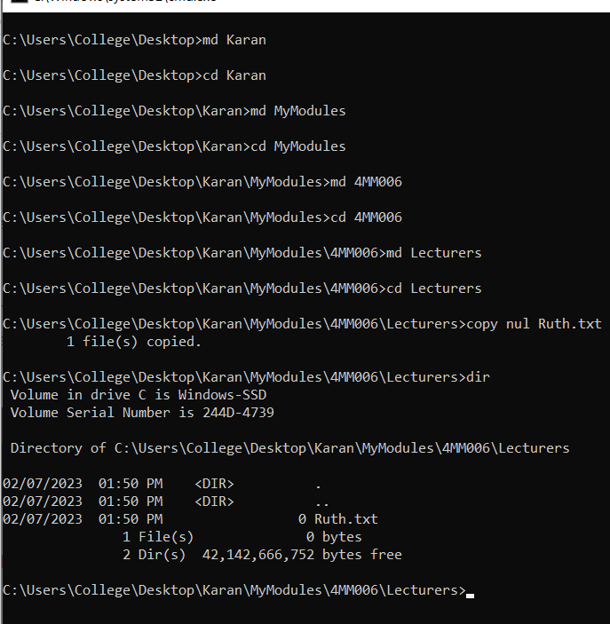
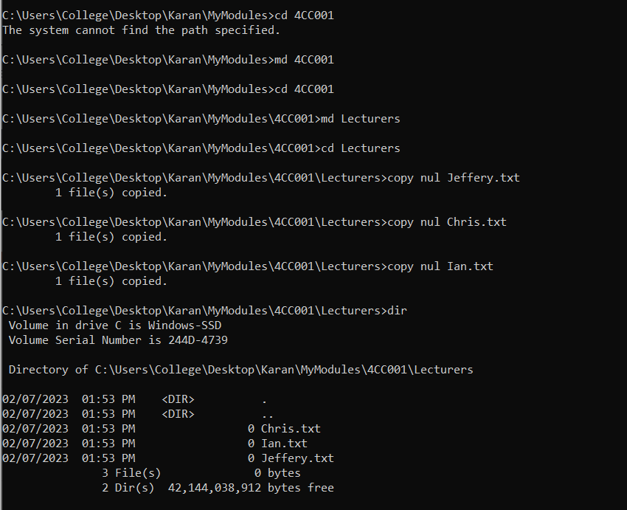
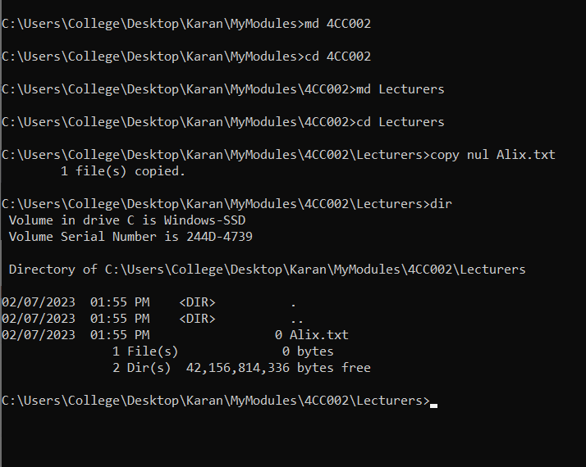
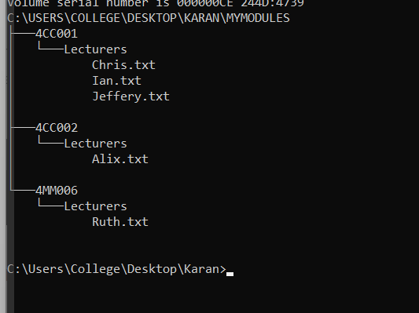
Task 3(Linux terminal) (10 marks)
Now, Boot into Linux operating system in virtualbox or Windows-SubSystem for LInux(On Windows)
- Write a command to Create a directory "test"
- Write the command to list all the directories/files inside the directory test
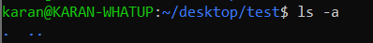
- Create a file "hello.txt" containing the word "Hello", inside the test directory.
- Display the content of hello.txt in the command line.
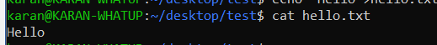
- Make directory test1 in the Desktop and copy hello.txt from test to test1
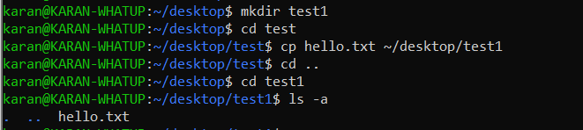
- Now delete the file hello.txt in the current directory

- Write a command to display your current directory.
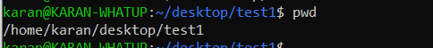
- Now rename the file to hello2.txt
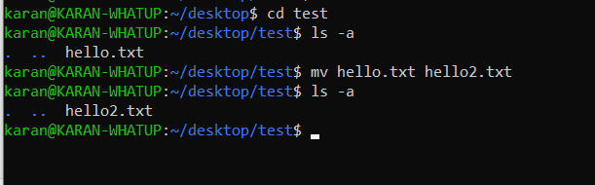
- Now navigate outside the directory test.
- Write the command to print the tree structure.
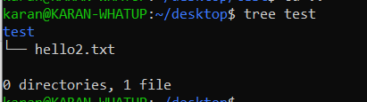

Task 4
Create the following directory structure (identical to the one that you created in Windows Command Prompt):
Note: MYMODULES must be inside <your_name> directory.
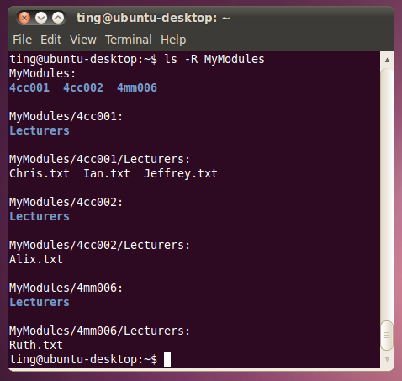

and insert it below (15 marks):
[Insert your picture here]

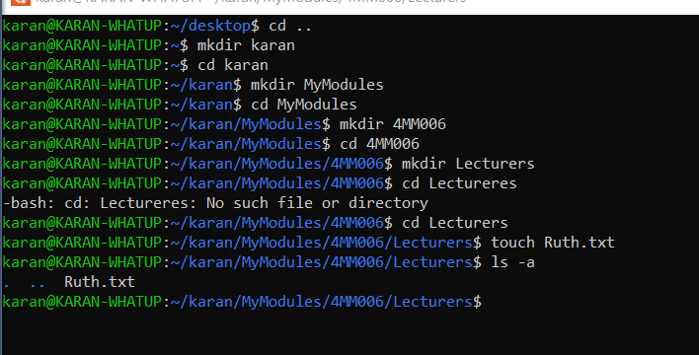
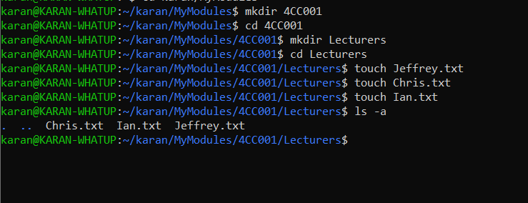

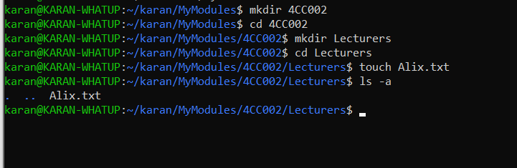

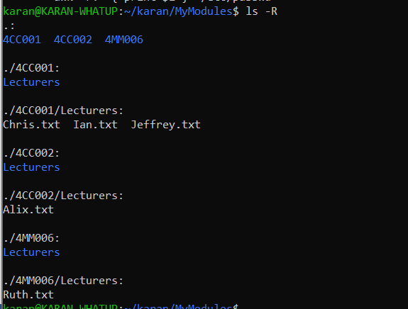

Task 5
Batch file material (50 marks in total)
Create a batch file (windows) YourNumber.bat from notepad (or your preferred text editor). Create this program on your home drive (or portable drive – USB) ready for execution.
The batch file should create a directory structure similar to the one create for the first section of this assignment but the directory entries should be provided from an input request from the batch file itself.
You should be able to create a root directory and directory structure and populate it if required. The batch file program will ask for names (input directory names and file names) to be used and have some form of error checking (empty – incorrect character, length, etc.) You can add other features such as being able to edit the new structure from within the batch file program (find and change a directory name).
Run batch file from windows prompt: YourNumber.bat <enter>

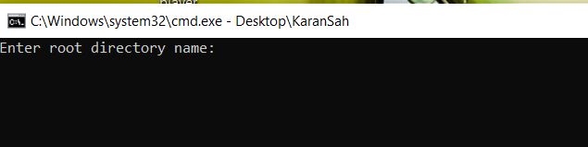

[Insert your picture(s) here] – Directory structure created / menu of batch file (inputs and output when batch file is executed) (10 marks)
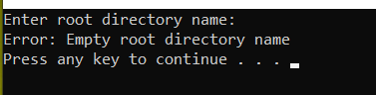

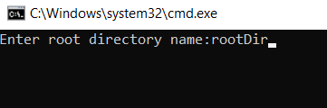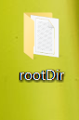
Inside rootDir:
Inside hello.txt
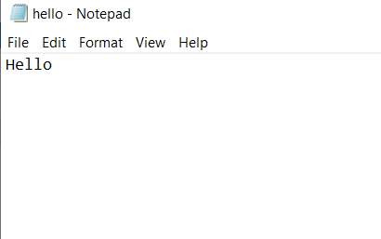
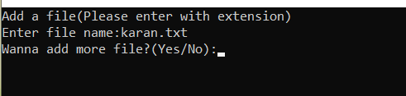


[Insert your text here] – batch file listing (script)(40 marks)

@echo off

:start
cls

rem Request root directory name
set /p rootDirName=Enter root directory name:
if "%rootDirName%" == "" (
echo Error: Empty root directory name
pause
goto start
)

rem Create root directory with the entered name
md %rootDirName%

rem List all directories/files inside the root directory
dir %rootDirName%

rem Create file "hello.txt" containing the word "Hello" inside the root directory
echo Hello > %rootDirName%\hello.txt

rem Display the content of hello.txt in the command line
type %rootDirName%\hello.txt

:subDirName
cls
rem Request the name of a subdirectory to be created in the Desktop
set /p subDirName=Enter the name of a subdirectory to be created in the Desktop:
if "%subDirName%" == "" (
echo Error: Empty subdirectory name
pause
goto subDirName
)

:addFile
cls
rem Create File
echo Add a file(Please enter with extension)

set /p file_name=Enter file name:
if "%file_name%" == "" (
echo File name can't be empty.
pause
goto addFile
)

echo.>%file_name%

set /p choice=Wanna add more file?(Yes/No):
if /i "%choice%" == "yes" goto add_file
if /i "%choice%" == "no" goto end
if not "%choice%" == "yes" if not "%choice%" == "no" (
echo ERROR
pause
goto addFile
)

:newRootDirName
cls
rem Request the new name for the root directory
set /p newRootDirName=Enter the new name for the root directory:
if "%newRootDirName%" == "" (
echo Error: Empty new directory name
pause
goto newRootDirName
)

rem Rename the root directory
ren %rootDirName% %newRootDirName%

rem Print the tree structure
tree %newRootDirName%

:end
cls
pause
exit

